**DS04 Activity 7 : Publish and Use the Model**

To perform publish and Use the Model. Will Be continuously From the Previous

Activity 6 (predict flight). To complete Activity 7 here are tasks.

Task 1: Set up the experiment as a web service, creating a predictive experiment (if the option to do this is not available, save and re-run the experiment). Then replace the **flight dataset** with **Enter Data Manually.** The same goes for the **Train Model** with Select Columns in Dataset.

Take Note! **Enter Data Manually.** the values predicted by for each input row.

* Input Row 1: Year, Month, Day of Month, Day Of Week, Carrier, Origin Airport ID, Dest Airport ID, CRS Dep Time, Dep Delay, DepDel15, CRS Arr Time, Arr Delay, ArrDel15, Cancelled
* Input Row 2: 2013,4,19,5,DL,11433,13303,837,-3,0,1138,1,0,0
* Input Row 3: 2013,4,19,5,DL,11433,13303,837,1,0,1238,1,0,0
* 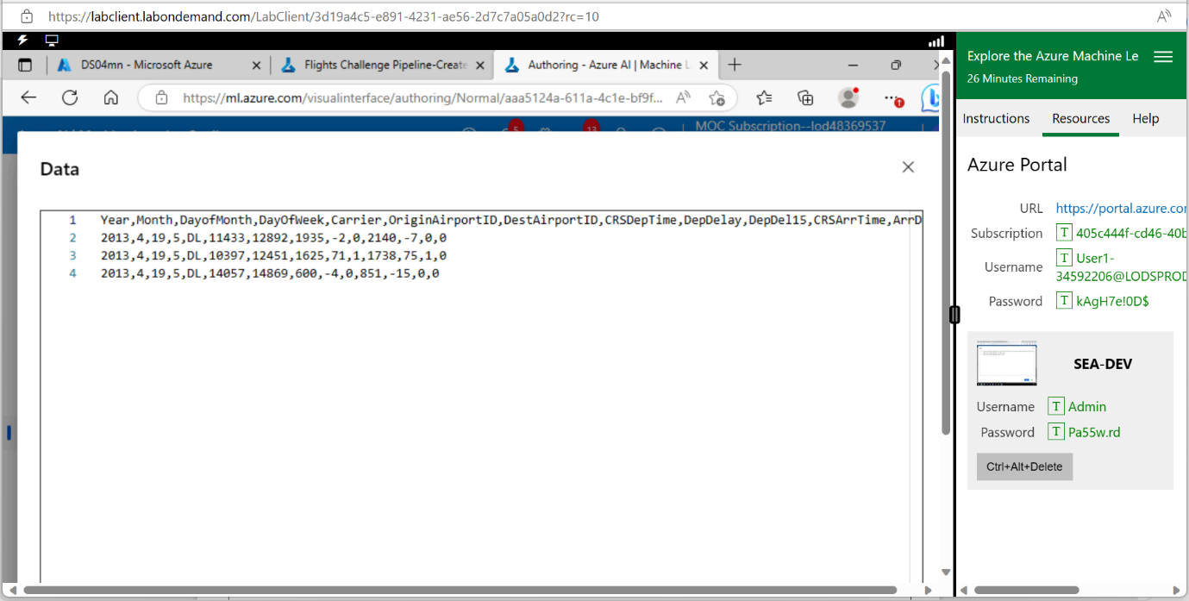Input Row 4: 2013,4,19,5,DL,11433,13303,837,2,0,1128,1,0,0

Take Note! You can get the dataset from This Location to **enter Manually**

Task 2: In the predictive experiment, add a **Select Columns in the Dataset** module and place it between the **Score Model** and Web service output modules. Use this to select only the **Scored Labels** column.

Task 3: Save and run the modified predictive experiment, and then deploy the web service.

After all the green line is completed. The **deploy** button will Appear then that’s wear start

Real-time endpoint.

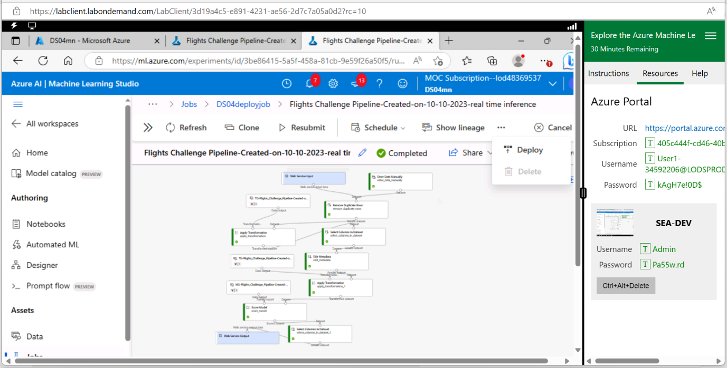Task 4: select **Deploy Real-time endpoint** then input the **name** ds04flightsjobs (your prefer name)

Compute type **Azure container Instance** lastly **Deploy.**

Finally, after the Run of The **Deploy,** it shows the **deployment state** is still **unhealthy**

On that is unable to run the test. But this is the step of how the experiment works

